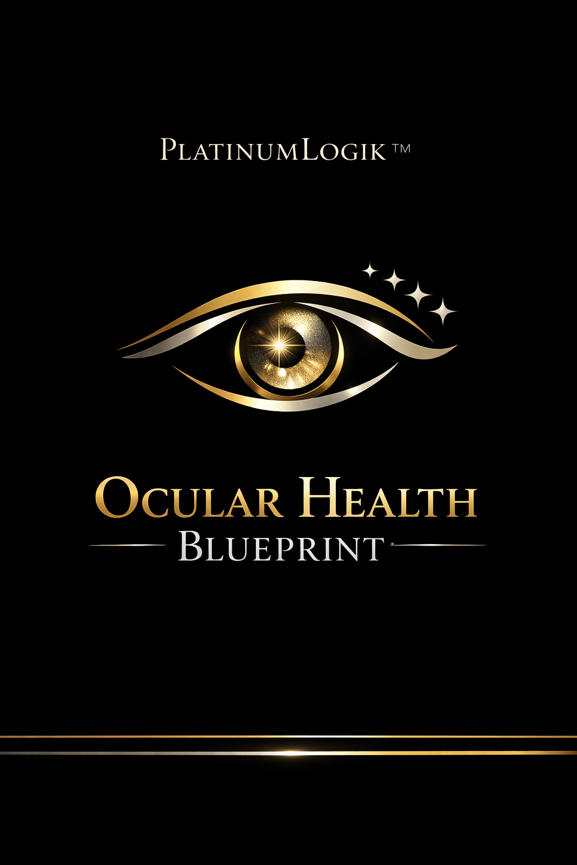
PlatinumLogik™ 7‑Day Ocular Health Jumpstart
Foods + daily methods to support comfort, clarity, and brighter-looking eyes

The 3 Pillars (Do These Daily)
- Greens: 2 cups leafy greens daily.
- Healthy fat daily (olive oil/avocado/eggs/nuts) OR fatty fish 2–3x/week.
- Hydration + full blinking during screen time.
7-Day Menu (Simple)
Day 1
- Breakfast: Golden Egg & Greens Skillet
- Main Meal: Salmon Sheet-Pan with Broccoli & Peppers
- Snack/Dessert: Citrus-Kiwi Sparkler
Day 2
- Breakfast: Berry-Citrus Chia Bowl
- Main Meal: Mediterranean Lentil & Spinach Stew
- Snack/Dessert: Pistachio-Cacao Trail Mix
Day 3
- Breakfast: Smoked Salmon Avocado Toast (Rye or Whole-Grain)
- Main Meal: Sweet Potato + Black Bean Bowl (Citrus Slaw)
- Snack/Dessert: Blueberry-Lemon Frozen Yogurt Bites
Day 4
- Breakfast: Green Smoothie (Macula Blend)
- Main Meal: Tuna + White Bean + Parsley Salad
- Snack/Dessert: Carrot-Pepper Crunch Plate with Hummus
Day 5
- Breakfast: Carrot-Ginger Oatmeal
- Main Meal: Mackerel & Tomato Olive Pasta (Whole-Grain)
- Snack/Dessert: Dark Chocolate + Orange ‘Square & Slice’
Day 6
- Breakfast: Greek Yogurt + Pistachio + Mango Cup
- Main Meal: Chickpea ‘Sunshine’ Curry (Turmeric + Spinach)
- Snack/Dessert: Mango-Chia ‘Pudding’ Cup
Day 7
- Breakfast: Golden Egg & Greens Skillet
- Main Meal: Sardine & Lemon Herb Bowl
- Snack/Dessert: Citrus-Kiwi Sparkler

